Natural Entrepreneurs – Scheme of Work

Title of Scheme: Natural Entrepreneurs

Duration: 12 weeks (12 hours)

Contents
Natural Entrepreneurs Biomimicry Design Process Graphic 2
Overview of Accompanying Power Point Slides and Sections 3
PHASE 0 – Introduction to Biomimicry (no platform) 4
Introduction to Biomimicry – 1 hour session 4
PHASE 1 – Define 6
Session 1 – Visioning the Future: Students consider a sustainable future, learn about the Sustainable Development Goals and create their Team. 7
Session 2 – Selecting Your Challenge: Teams review the Challenges and select one they would like to work on. 8
Session 3 – Understanding your Challenge: Teams understand the context of their Challenge. 9
Session 4 – Writing Research Questions: Teams write research questions 10
PHASE 2 - Discover 11
Session 5 – Exploring Nature for Solutions (part 1) Teams explore nature for solutions 12
Session 6 – Explore Nature for Solutions (part 2): Teams continue to explore nature for solutions 13
PHASE 3 - Create 14
Session 7 – Create Design Solution (pt. 1) Teams begin to create their Design Solution 15
Session 8 – Create Design Solution (pt.2): Teams continue to create their Design Solution 16
Session 9 – Evaluating and Improving: Teams use Nature’s Unifying Patterns to evaluate their Design Solutions 17
PHASE 4 – Communicate 18
Session 10 – Communicating: Students create a ‘Pitch Deck’ to communicate their Design Solutions 19

Natural Entrepreneurs Biomimicry Design Process Graphic
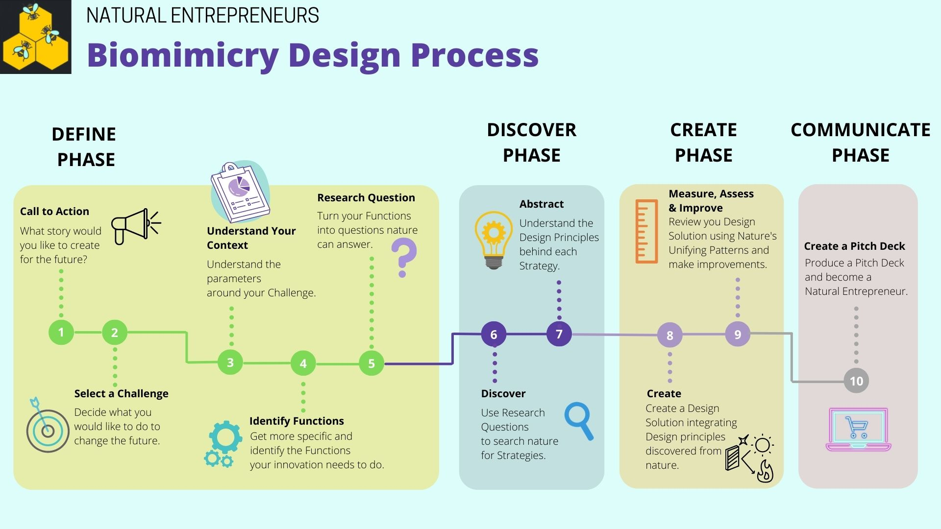

Overview of Accompanying Power Point Slides and Sections
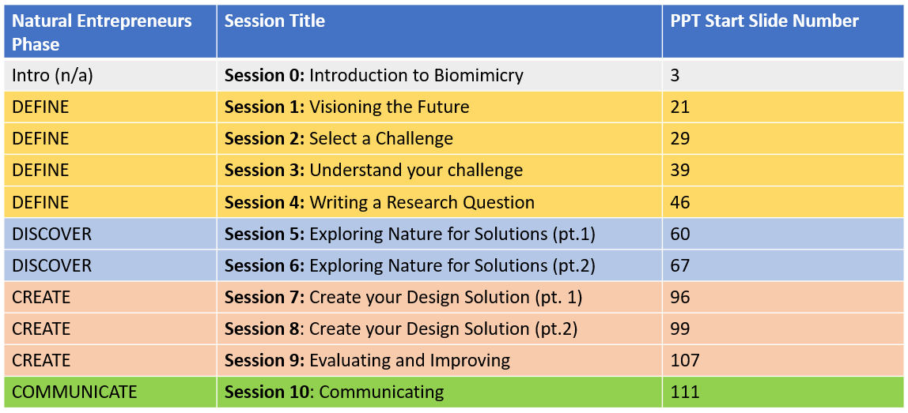

PHASE 0 – Introduction to Biomimicry (no platform)

In this phase students are introduced to biomimicry and gain an overview of the potential for biomimicry to help solve human design challenges.

Students will:
- Learn how biomimicry has helped solve human design challenges.
- Become familiar with key terminology (function, strategy).
- Practice key skills in biomimicry thinking.

Introduction to Biomimicry – 1 hour session
Learning Objectives | Suggested Teaching Activities | Teaching Resources | Outputs
Students:  - Are able to consider the functions and strategies of nature  - Understand that these functions and strategies can be applied to human design challenges. | Starter (15 mins)  Select an object from nature  Students choose a natural object to examine. These could be selected from a pile of objects already collected by the teacher, or this activity could be done outside.  Ask the students to sketch their object on a piece of paper.  Consider the function  Once students have finished their sketch, ask them to consider what their object ‘does’ i.e. what is its function? There may several functions – they can label their sketch with them.  Learning check: whole class feedback.  Consider the strategy  For each function, ask students to think about how their object achieves this i.e. the strategy for doing so.  For example, if someone had chosen twig from a tree, the function might have been ‘strength’ and the strategy could have been ‘moving and bending in the wind to absorb forces’.  Main (30 mins)  Function Hunt  Next, explain to the students that there are a large number of functions which we find in nature, which can in turn be useful to us in our designs. It can be useful to search nature for specific functions and then to consider the strategy nature uses to achieve these functions.  In this activity students go out into a natural or semi-natural space (an area of trees, grass or similar) and search for a range of functions. A list of functions as printable cards is available here - https://asknature.org/resource/function-junction/.  Learning check:  A conversation can be had at the end of this activity about what functions were found, how some objects cross between functions, and how the strategies differ to achieve similar functions across different objects.  Introducing the Biomimicry Concept  Make use of the PowerPoint to provide a definition of Biomimicry and how it can influence design.  Plenary (10 mins)  Biomimicry Quiz  Give out the quiz sheet containing four images (PPT slide 12) – a mixture of natural objects. For each image students should consider (in groups) what inspired what design each natural object might have inspired.  Answers are found on the accompanying PowerPoint along with explanations. | A selection of natural objects. The object should be living, or something which has been alive.  Paper and Pens  PPT 3-5  PPT 6  PPT 7-11  PPT 12-20 | An annotated sketch with functions and strategies labelled.  Individual or group scavenger hunt sheets with natural objects placed on top.  Quiz sheets (printed from ppt) with answers and descriptions written down.

PHASE 1 – Define

In this phase students are introduced to the NatEnt Platform, set up their Team and select a Challenge to work on. They consider the context for their selected Challenge and needs of users. Finally, they write Research Questions to explore.

Students will:
- Imagine a sustainable future in their local area.
- Develop an understanding of the Sustainable Development Goals.
- Form a biomimicry Team.
- Identify a Challenge to work on in their Team.
- Define the Context and Need for their chosen Challenge Topic.
- Identify the Functions their Design Solution needs to deliver.
- Write Research Questions to help explore nature for ideas.

Session 1 – Visioning the Future: Students consider a sustainable future, learn about the Sustainable Development Goals and create their Team.

Learning Objectives | Suggested Teaching Activities | Teaching Resources | Outputs
Students:  - Are able to think about their local area and how it might change in the future.  - Understand what the Sustainable Development Goals are. | Starter (20 mins)  Provide students with the Vision sheet (Define 1 – Visioning a Sustainable Future). Ask them to think about their local area in 2030…what might have changed for the better? You can use these prompt questions:  - What does it look like, sound like, feel like?  - What do you notice is different from today? What’s new? What’s missing?  - Consider the interactions between people, the environment, buildings, plants and animals. What do you notice about the technology people are using and the way the buildings are designed?  - How are streets designed to encourage interaction between people, and how is health and well-being supported?  - Inside the buildings, how are they heated and powered, and what services do they offer?  Learning check: whole class feedback.  Main (20 mins)  Introduce the Sustainable Development Goals (see PPT); these represent 17 globally agreed goals for a sustainable future. Discuss which might be relevant to their vision. Option to watch video explaining the SDGs (2 minutes).  Learning check: students write down own ideas followed by whole class.  Plenary (10 mins)  Explain that students will work on a related SDG Challenge over the coming weeks, using biomimicry as a process to find a Design Solution. They will be using the NatEnt Platform to record their research, share with others and to learn from other Teams. Ask students to form Teams and select a Team name. | PPT 21-28  Define 1 – Visioning a Sustainable Future  Define 2 – Team Sheet | Completed Vision sheets  For each Team – Team name, member usernames and short Team introduction
Before next session | Set up Teams in the platform Admin before the next session. Remember to keep a record of the password for each Team in a spreadsheet for easy access.

Session 2 – Selecting Your Challenge: Teams review the Challenges and select one they would like to work on.

Learning Objectives | Suggested Teaching Activities | Teaching Resources | Outputs
Students:  - Understand the NatEnt Platform is a tool to help them explore nature to solve Design Challenges.  - Are familiar with the work other Teams are doing on the NatEnt Platform.  - Have selected a Challenge they wish to work on in their Team. | Starter (10 mins)  Watch the video which introduces the NatEnt Platform to students. Explain that students will be working in their Teams to solve a Challenge which they will select during this session.  [The following activities require the NatEnt Platform]  Main (30 mins)  Provide Teams and Team members with their individual password. Ask students to login into their Team and add the short Team description they developed in the last session.  Ask Teams to visit the Model Team (see Browse Other Teams tab) and read the text this Team has entered. Explain that over the next few weeks each Team will be creating a similar page for their own Team based on a Challenge they wish to address. What questions do Teams have?  Next, tell Teams to move to the Select a Challenge page and read through the Challenges presented. Each Team selects a Challenge they wish to address.  Learning check: Teams report to class why they selected their challenge.  Plenary (10 mins)  Teams make notes on factors which might affect their Challenge (see PPT for prompt questions); this will be completed in Session 3. | PPT 29-38 | Team profile completed  Teams have selected their Challenge on the Platform
Before next session | Login to the Platform using your teacher account and moderate any content which Teams have added. Teams will then be able to see content from all Teams, not just their own.

Session 3 – Understanding your Challenge: Teams understand the context of their Challenge.

Learning Objectives | Suggested Teaching Activities | Teaching Resources | Outputs
Students:  - Review the context of their selected Challenge.  - Understand user needs related to their selected Challenge. | Starter (5 mins)  Remind Teams that in the last session they selected a Challenge to work on. Remind Teams that they should not change their Challenge as it will hide any related data they add later.  [The following activities require the NatEnt Platform]  Main (30 mins)  Teams need to understand their Challenge before they can create a solution. Ask Teams to consider the context in which their Design Solution will operate and the needs of people it will benefit. Provide Teams with the Context & Needs worksheet to complete – they can come back and refine their thinking later.  An example is provided in the PPT, as well as questions Teams can consider. Teams can refer back to the Platform to read about their selected Challenge.  Nature is inherently sustainable. Nature’s Unifying Patterns outline ten principles which underly nature’s sustainability. Teams will use these in Session 9 when they review their work. You might like to introduce them now and ask Teams which of Nature’s Unifying Patterns are relevant to their Context and Needs.  Learning check: each Team reports Context statement and list three key Needs.  Plenary (15 mins)  One member of each Team logs into the Platform to input the Teams context and needs data. Other Team members log in and look at the work of other Teams; they should comment/appreciate two other Teams each. Remind students that they can search other Teams by topic to help them find relevant information. | PPT 39-45  Define 3 - Context & Needs  Define 4 - Nature’s Unifying Patterns | Completed Context & Needs worksheet  Data entered into Platform  Review of the Define Phase
Before next session | Login to the Platform using your teacher account and moderate any content which Teams have added.

Session 4 – Writing Research Questions: Teams write research questions

Learning Objectives | Suggested Teaching Activities | Teaching Resources | Outputs
Students:  - Identify the Functions their Design Solution will need to deliver.  - Develop Research Questions.  - Review the work of other Teams in the NatEnt Platform. | Starter (10 mins)  Introduce Teams to Functions – what their Design Solution needs to do in order to address their Challenge. Definitions and examples in the PPT.  Learning check: ask students to provide examples of Functions for common objects e.g. mobile phone, cup, car.  [The following activities require the NatEnt Platform]  Main (30 mins)  Provide Teams with the Functions handout containing a list of 26 Functions. Ask Teams to identify at least two Functions which their Design Solution will need to do in order to address their Challenge. Note that Functions are always verbs and will usually need to be paired with an object e.g. absorb (verb) sound (object); reflect (verb) heat (noun). For additional support, you can provide a copy of the Biomimicry Taxonomy which contains a more detailed Function list - http://toolbox.biomimicry.org/wp-content/uploads/2015/01/AN_Biomimicry_Taxonomy.pdf.  Once Teams have selected at least two Functions, they need to turn these into Research Questions nature can help answer. They do this using the stem sentence “How does nature…” and adding their selected Function. See examples in the PPT. Remind Teams that they can return to add more Research Questions later.  Learning check: Teams feedback two Research Questions each to whole class.  Plenary (15 mins)  One member of each Team logs into the Platform to input the Teams Research Question(s) data. Other Team members log in and look at the work of other Teams; they should comment/appreciate two other Teams each. Remind students that they can search other Teams by topic to help them find relevant information.  Learning check: ‘Muddiest Point’ – individually students write down ‘what (if anything) do you find unclear about Functions and Research Questions’ (collect in and review responses). | PPT 46-59  Define 5 - Functions  Define 6 – Teacher Guidance on Challenges and Function | Research Questions entered into the Platform
Before next session | Login to the Platform using your teacher account and moderate any content which Teams have added.

PHASE 2 - Discover

In this Phase students will explore nature and discover how nature delivers the Functions you need to integrate into your Design Solution.

Students will:
- Find and research organisms in nature.
- Explore how they deliver the Functions they are interested in.
- Discover the Strategy they use to perform each Function.
- Take this information to write a Design Principle which can be applied within your Challenge.

Session 5 – Exploring Nature for Solutions (part 1) Teams explore nature for solutions

Learning Objectives | Suggested Teaching Activities | Teaching Resources | Outputs
Students:  - Use a range of approaches to explore nature and find answers to their Research Questions.  - Identify organisms which can help answer their Research Questions.  - Record their research using Species Report Cards. | Starter (10 mins)  Introduce Teams the different ways they can explore nature for solutions:  - Go outside and look.  - Use the ‘Ask Nature’ website.  - Research science literature online.  Use the PPT to explain how to use the Species Report Card, focusing on steps 1-4.  [The following activities require the NatEnt Platform]  Main (30 mins)  If in the classroom, encourage Teams to search the Ask Nature website using their Research Question (search via Function). Teams should use the Species Report Cards to record helpful organisms they discover. Examples of completed Species Report Cards are available in the NatEnt platform.  Suggest that within each Team, students work in pairs to find at least two relevant organisms for each Function and add details to a separate Species Report Card. Encourage Teams to search for scientific papers on organisms which are the most promising – are there ways this species has already be used in biomimicry? What can they learn from this?  Learning check: each Team showcases one organism and explain what they can learn from it.  Plenary (5 mins)  Ask Teams to review their progress and plan how they will continue their research before the start of the next session. | PPT 60-66  Discover 1 - Species Report Card | 2-4 completed Species Report Cards per Team
Before next session | Login to the Platform using your teacher account and moderate any content which Teams have added.

Session 6 – Explore Nature for Solutions (part 2): Teams continue to explore nature for solutions

Learning Objectives | Suggested Teaching Activities | Teaching Resources | Outputs
Students:  - Understand how their research from nature can help create a Design Solution.  - Extract ideas from nature into a form which can be used to create a Design Solution. | Starter (10 mins)  Teams should update themselves on any research they have done in between sessions.  Main (20 mins)  Explain how Teams extract Design Principles from their research – see PPT. This is difficult, and time needs to be spent ensuring Teams understand this step. Use as many examples from the PPT as you feel necessary.  Teams can continue their research and completing the Species Report Cards. Aim to have research for at least three organisms completed. If appropriate, you can extend this for an extra session, or Teams can return to do more research later.  Learning check: each Team showcases one organism and the Design Principle.  [The following activities require the NatEnt Platform]  Plenary (20 mins)  One member of each Team logs into the Platform to input the data from the Species Report Cards [TASK: Share Your Natural Strategies and Design Principles]. Other Team members log in and look at the work of other Teams; they should comment/appreciate two other Teams each. Remind students that they can search other Teams by topic to help them find relevant information.  Learning check: display completed Species Report Cards and ask students to add comments to other Teams using post-it notes. | PPT 67-95  Discover 1 – Species Report Card | 2-4 completed Species Report Cards per Team  Species Report Card data entered onto Platform
Before next session | Login to the Platform using your teacher account and moderate any content which Teams have added.

PHASE 3 - Create

In this Phase students turn their ideas into Design Solutions and reflect on how their Design Solution meets their Challenge.

Students will:
- Identify their best design ideas from nature.
- Consider how they can be integrated into a Design Solution.
- Create their Design Solution.
- Present their idea for other Teams to see.
- Reflect on how their Design Solution meets their Challenge and how biomimicry is included.

Session 7 – Create Design Solution (pt. 1) Teams begin to create their Design Solution

Learning Objectives | Suggested Teaching Activities | Teaching Resources | Outputs
Students:  - Research how other students have created Design Solutions.  - Review their own research and identify key ideas for their Design Solution. | Starter (15 mins)  Ask Teams to open the Youth Design Challenge website – this is a US-based biomimicry design challenge for schools. Ask Teams to select one example they like and explain why.  Learning check: Teams explain selection to whole class.  [The following activities require the NatEnt Platform]  Main (25 mins)  Ask Teams to open their Team page (see Your Team Page tab) and remind themselves of the Context & Needs they identified. Explain that they will start to create their Design Solution during this session, and they should remember the Context & Needs.  Explain that Teams now need to use their research to create their Design Solution. Look at the research they have entered into the Platform – which ideas do they think might be used in their Design Solution? Look at their Design Principles – how can these be used to create a Design Solution? Share the two examples in the PPT.  Learning check: Teams complete sentence ‘My design will solve the challenge of [enter challenge] by [enter design idea 1] and [enter design idea 2].  Plenary (10 mins)  Ask Teams to review their progress and plan how they will continue their research before the start of the next session. Remind them that by the end of the next session they will need to have completed an annotated drawing of their Design Solution. | PPT 96-98 | Initial Design Solution Ideas
Before next session | Login to the Platform using your teacher account and moderate any content which Teams have added.

Session 8 – Create Design Solution (pt.2): Teams continue to create their Design Solution

Learning Objectives | Suggested Teaching Activities | Teaching Resources | Outputs
Students:  - Produce a biomimicry Design Solution.  - Create an annotated drawing detailing their Design Solution. | Starter (5 mins)  Remind Teams that they need to complete an annotated drawing of their design solution by the end of this session. There is an optional activity to help create more ideas (see PPT)  Show the example in the PPT to provide an example of what might be expected. This is quite a detailed example, and you might wish to focus attention on the ‘How does it work?’ and ‘From nature to human application’ slides. You can also refer Teams to this website which has nice student design drawings - https://bouncingideas.wordpress.com/category/student-design-projects/.  Teams should update themselves on any research done in between sessions.  Main (35 mins)  Teams continue their Design Solution work from Session 7. Draw their attention to the requirements for their Design Solution (see PPT).  You could ask each Team to provide a 60 second pitch and other Teams to provide one feedback point each.  The NatEnt Platform allows Teams to upload a drawing (jpeg/png/pdf) and/or a video (they could record themselves explaining their design drawing).  Learning check: see 60 second pitch above or gallery display and comments via post-its.  [The following activities require the NatEnt Platform]  Plenary (10 mins)  One member of each Team logs into the Platform to upload their Design Solution. Other Team members log in and look at the work of other Teams; they should comment/appreciate two other Teams each. Remind students that they can search other Teams by topic to help them find relevant information. | PPT 99-106 | Annotated drawing of Design Solution  Design Solution uploaded to Platform
Before next session | Login to the Platform using your teacher account and moderate any content which Teams have added.

Session 9 – Evaluating and Improving: Teams use Nature’s Unifying Patterns to evaluate their Design Solutions

Learning Objectives | Suggested Teaching Activities | Teaching Resources | Outputs
Students:  - Analyse and evaluate their Design Solution and make recommendations for future improvements. | Starter (10 mins)  Remind Teams about Nature’s Unifying Patterns (introduced in Session 3). Ask Teams to read through the NUPs and decide which three are most aligned with their Challenge and Design Solution.  Main (30 mins)  Provide Teams with the Design Solution review sheet. Ask them to think about their Design Solution and remind them that design is a process of constant improvements (imagine is the phone had never been improved). Teams should work through the review sheet to think about where they have met their Challenge and where improvements can be made.  Learning check: each Team presents one idea for improving their Design Solution.  [Teams can go back and improve their Design Solution if they wish and upload version 2]  [The following activities require the NatEnt Platform]  Plenary (10 mins)  One member of each Team logs into the Platform to add their reflections. Other Team members log in and look at the work of other Teams; they should comment/appreciate two other Teams each. Remind students that they can search other Teams by topic to help them find relevant information. | PPT 107-110  Create 1 - Context & Needs Review  Create 2 – Natures Unifying Patterns Questions  Create 3 – Natures Unifying Patterns | Completed Design Solution review sheet  Review results added to Platform
Before next session | Login to the Platform using your teacher account and moderate any content which Teams have added.

PHASE 4 – Communicate

In the final Phase students consider the next steps for communicating their Design Solution to others and maybe even bringing their idea to the market.

Students:
- Analyse the next steps to bring their Design Solution to market.
- Create a pitch deck to sell their Design Solution to an appropriate audience.

Session 10 – Communicating: Students create a ‘Pitch Deck’ to communicate their Design Solutions

Learning Objectives | Suggested Teaching Activities | Teaching Resources | Outputs
Students:  - Are able to consider the next steps for bringing their Design Solution to the market.  - Develop a pitch deck to market their Design Solution to an appropriate audience. | Starter (10 mins)  Ask Teams to think about what the next steps are to move their Design Solution forward. Suggestions are included in the PPT, including carrying out further research, producing a prototype and seeking investment funding.  [The following activities require the NatEnt Platform]  Main (30 mins)  Based on their next move above, Teams are to create a Pitch Deck. Provide them with the worksheet to help form their ideas. They can also refer to the suggestions on the Platform.  [Depending on curriculum aims, you might encourage Teams to produce a Business Canvas (Business Studies), or focus on the science research that might be required to move forward. This task could include homework and extend into an extra session. You might also extend this into a Dragon’s Den style presentation]  An easy way for Teams to create their pitch deck is using PowerPoint and video conferencing software such as Zoom or Teams. Teams simply record themselves presenting their pitch. Teams can get more complicated using video editing software such as OpenShot, but remember that it is their idea that counts most.  Learning check: Teams present their pitch.  Plenary (10 mins)  One member of each Team logs into the Platform to upload Pitch Deck. Other Team members log in and look at the work of other Teams; they should comment/appreciate two other Teams each. Remind students that they can search other Teams by topic to help them find relevant information.  All Team members complete the Final Review questions – contact the project to receive a set of results for your Teams. | PPT 111-115  Communicate 1 - Pitch Deck | Pitch Deck uploaded to Platform
Before next session | Login to the Platform using your teacher account and moderate any content which Teams have added.

